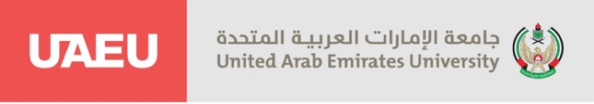
Department of Mass Communication
Internship Fall 2025
Practicum (51)
Submitted to Professor Badreya Al-Jenaibi

Internship weekly report
Student name: Sarah ali almesmari Student ID: 202104639
Training organization: Fujairah police at UAEU Week:8
Field Supervisor: Salma Albalghouni
Academic supervisor: prof. Badreya Aljenaibi

During the eighth week of my training at the Fujairah Police General Headquarters, I was assigned a research task to determine the number of beneficiaries of news posts shared by the Fujairah Police on Instagram. I worked on analyzing the posts and tracking the engagement and reach to understand how many people are benefiting from the shared information.
This activity helped me gain experience in social media analytics and provided insight into the effectiveness of public communication and awareness campaigns conducted by the police headquarters.

